Test # 297
Instrument Name Consistometer
Instrument Type Consistometer
Test Start 07/05/01 16:36
Test Stop 16:24:38
Well ID # CFL-110 test
Customer KOGALYM
Cement Class G
Additives 0.75%CFL-110+Defoamer
Cement Mfr DYKERHOFF
BHCT 65
BHST 65
Density 1880
Fluid Loss
Job Type research
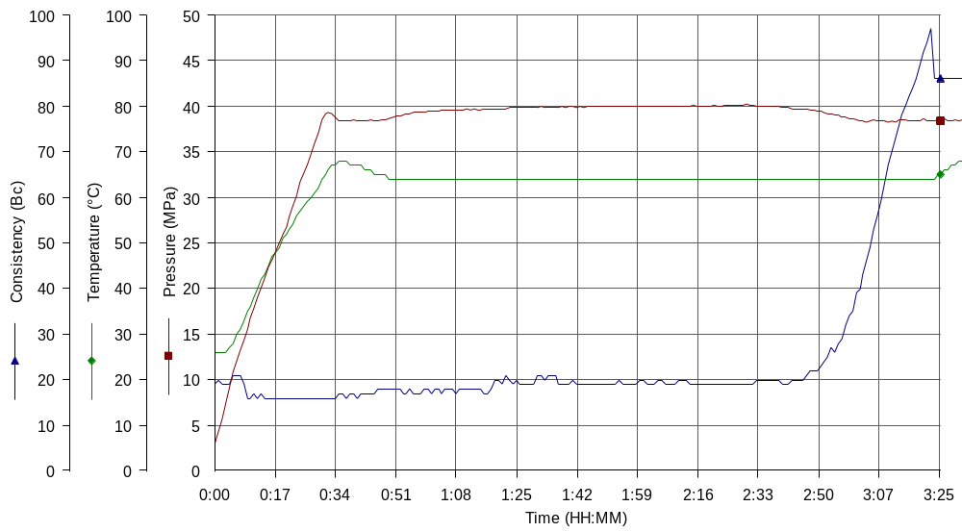
Comments MPa: 38.3(31min); T: 65C(31min); Kogalym cement; tap water, premix CFL-110

